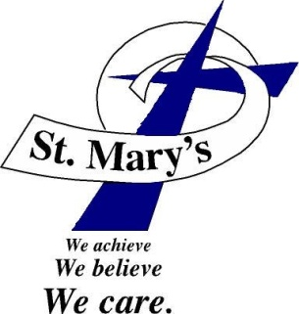
St. Mary’s School
Fr. Dana Clark, Pastor • Patti Park, Principal

St. Mary’s After Regular Time (SMART) Program
Opens upon dismissal of full school days
at 3:34 p.m. and closes at 5:30 p.m. Monday-Friday

What is SMART?
• After school program • Academic program
• Social enrichment program • For any St. Mary’s Student
• Pre-K – 6th Grade

Be SMART and sign up

for the St. Mary’s after

school program today!
School Enrollment: August 3, 2023 (Noon – 6 p.m.)
785-726-3185

